MINI PROJECT REPORT
A Mini Project Report on Vaultra Bank – Online Banking and Account Registration Portal
submitted to the
Department of Computer Science
St. Joseph’s College (Autonomous)
Affiliated to Bharathidasan University, Tiruchirappalli
in partial fulfilment of the requirements for the award of the Degree of
BACHELOR OF SCIENCE IN COMPUTER SCIENCE
BY
A. ARO JOSHUVA
(Reg. No: 25UCS549)
under the guidance of
Mrs. M. Nasreen, M.C.A., M.Phil
Dr. A. Janet Rajeswari M.Sc., M.Phil., Ph.D

Department of Computer Science
St. Joseph’s College (Autonomous)
Accredited at A++ Grade (Cycle IV) by NAAC
Special Heritage Status Awarded by UGC
Tiruchirappalli - 620 002
Academic Year 2026 – 2027

Mrs. M. Nasreen, M.C.A., M.Phil.  Dr. A. Janet Rajeswari M.Sc., M.Phil., Ph.D  Project Guides  Department of Computer Science  St. Joseph’s College (Autonomous)  Tiruchirappalli - 620 002 | 

CERTIFICATE
This is to certify that the report on the Mini Project entitled Vaultra Bank – Online Banking and Account Registration Portal submitted to the Department of Computer Science, St. Joseph’s College (Autonomous), Tiruchirappalli - 620 002, in partial fulfillment for the award of the Degree of Bachelor of Science in Computer Science, is an original work done by Mr. A. Aro Joshuva (25UCS549), under my supervision and guidance during the academic year 2026 - 2027.

Signature of the Coordinator  Dr. J. Antony John Prabu  Coordinator  Department of Computer Science  St. Joseph’s College (Autonomous)  Tiruchirappalli-620 002 | Signature of the Guide  Mrs. M. Nasreen, M.C.A., M.Phil.  Project Guide  Department of Computer Science  St. Joseph’s College (Autonomous)  Tiruchirappalli-620 002
Submitted for the viva-voce examination on __________________
Signature of the External Examiner  Date: | Signature of the Internal Examiner  Date:

CERTIFICATE OF SUSTAINABLE DEVELOPMENT GOALS (SDG) COMPLIANCE
This is to certify that the Mini Project entitled Vaultra Bank – Online Banking and Account Registration Portal has been done in alignment with the United Nations Sustainable Development Goals (SDGs) by Mr. A. Aro Joshuva (Reg. No.: 25UCS549), a student of the Department of Computer Science, St. Joseph’s College (Autonomous), Tiruchirappalli – 620 002, in partial fulfillment of the requirements for the award of the Degree of Bachelor of Science in Computer Science.
This Mini Project was carried out under my supervision and guidance during the academic period 2026 - 2027. The work is found to be original and reflects the student’s ability to apply sustainability principles in software development.

Signature of the Coordinator  Dr. J. Antony John Prabu  Coordinator  Department of Computer Science  St. Joseph’s College (Autonomous)  Tiruchirappalli-620 002 | Signature of the Guide  Mrs. M. Nasreen, M.C.A., M.Phil.  Project Guide  Department of Computer Science  St. Joseph’s College (Autonomous)  Tiruchirappalli-620 002
Submitted for the viva-voce examination on __________________
Signature of the External Examiner  Date: | Signature of the Internal Examiner  Date:

Mr. A. Aro Joshuva
Reg. No.: 25UCS549
Department of Computer Science
St. Joseph’s College (Autonomous)
Tiruchirappalli - 620 002

DECLARATION
I hereby declare that the Mini Project Report entitled Vaultra Bank – Online Banking and Account Registration Portal is a record of original work done by me during the period of study, under the guidance of Mrs. M. Nasreen, M.C.A., M.Phil. and Dr. A. Janet Rajeswari M.Sc., M.Phil., Ph.D. Department of Computer Science, St. Joseph’s College, Tiruchirappalli – 620 002.
I further declare that any part of this Mini Project has not been submitted elsewhere for the award of any Degree or Diploma at any other University or Research Institute.

Signature of the Candidate

ACKNOWLEDGEMENT
I express my sincere gratitude to the Almighty for giving me the strength and the opportunity to complete this mini project successfully.
I am thankful to the Principal and the Management of St. Joseph's College (Autonomous), Tiruchirappalli, for providing the facilities and a supportive academic environment for carrying out this work.
I extend my heartfelt thanks to Dr. J. Antony John Prabu, Coordinator, Department of Computer Science, for his encouragement and for the opportunity to take up this mini project.
I am deeply indebted to my project guides, Mrs. M. Nasreen, M.C.A., M.Phil., and Dr. A. Janet Rajeswari, M.Sc., M.Phil., Ph.D., for their valuable guidance, constant support and suggestions during the development of the Vaultra Bank Portal.
I also thank all the faculty members of the Department of Computer Science, my parents and my friends, whose motivation and help made this project possible.

A. ARO JOSHUVA

ABSTRACT
Vaultra Bank is a web-based digital banking website developed as a mini project to demonstrate how a customer can open and operate a bank account entirely online. In the traditional process a customer must visit a branch, collect and fill paper account-opening and KYC forms, attach photocopies of identity documents and wait for manual verification. This is slow, depends on office hours and often leads to incomplete or incorrect forms.
The portal replaces this with an online workflow. A visitor opens an attractive landing page, registers through a seven-step form (Personal, Contact, Employment, Banking, Security, Nominee and Documents) and the system validates every field, for example a 12-digit Aadhaar number, a 10-digit mobile number, a PAN in the format ABCDE1234F, a 6-digit PIN code and a strong password. After the documents are attached and the declarations are accepted, the system verifies the details, generates a Customer ID, a 16-digit account number, a CIF number, an IFSC code, a UPI ID and a virtual debit card, and saves the customer record.
The registered customer logs in with a username and password and reaches a dashboard showing the available balance, account details and recent transactions. From the dashboard the customer can view and edit the profile, deposit, withdraw and transfer money using a transaction PIN, search and filter the transaction history, download a passbook, view card details, check loan eligibility, calculate and book a fixed deposit, change the password or notification settings, and log out. A forgot-password option uses a security question.
The front end is built with HTML, CSS and JavaScript in a single responsive page with animated transitions. Customer data is kept in the browser’s local storage, so no server or database software is needed. The project is a demonstration system: no real funds are held or transferred.
TABLE OF CONTENTS
Acknowledgement 5
Abstract 6
Chapter 1: Introduction 9
1.1 Overview 9
1.2 Problem Statement 9
1.3 Objectives 9
1.4 Scope of the Project 10
1.5 Advantages of the Project 10
1.6 Organisation of the Report 10
Chapter 2: System Analysis 11
2.1 Existing System 11
2.2 Proposed System 11
2.3 Feasibility Study 11
2.4 Functional Requirements 11
2.5 Non-Functional Requirements 12
Chapter 3: System Requirements 13
3.1 Hardware Requirements 13
3.2 Software Requirements 13
3.3 Browser Requirements 13
Chapter 4: Technologies Used 14
4.1 HTML (HyperText Markup Language) 14
4.2 CSS (Cascading Style Sheets) 14
4.3 JavaScript 14
4.4 Local Storage 15
4.5 Responsive Web Design 15
4.6 Summary of Technologies 15
Chapter 5: System Design 16
5.1 System Architecture 16
5.2 Modules of the System 16
5.3 System Flow 16
5.4 Registration Module 17
5.5 Login Module 18
5.6 Dashboard Module 18
5.7 Data Storage Design 18
Chapter 6: Implementation 20
6.1 Step 1: Opening the Vaultra Bank Website 20
6.2 Step 2: Landing Page 20
6.3 Step 3: Account Registration 20
6.4 Step 4: Personal Information 21
6.5 Step 5: Contact Information 21
6.6 Step 6: Employment Details 22
6.7 Step 7: Banking Details 23
6.8 Step 8: Account Security 24
6.9 Step 9: Nominee Details 25
6.10 Step 10: Document Upload 26
6.11 Step 11: Form Validation 26
6.12 Step 12: Registration Confirmation 27
6.13 Step 13: Login Page 28
6.14 Step 14: User Dashboard 30
6.15 Step 15: Banking Services and Quick Actions 31
6.16 Step 16: Recent Transactions 35
6.17 Step 17: Logout 35
Chapter 7: Testing 37
7.1 Testing Approach 37
7.2 Test Cases 37
7.3 Form Validation Testing 37
7.4 Login Testing 38
7.5 Registration Testing 38
7.6 Test Observations 38
Chapter 8: Conclusion and Future Enhancement 39
8.1 Conclusion 39
8.2 Limitations 39
8.3 Future Enhancements 39
Chapter 9: Bibliography 40

CHAPTER 1: INTRODUCTION

1.1 Overview
Banking has moved from branch counters to mobile phones and browsers. Customers now expect to open an account, check a balance, send money and book a deposit from anywhere at any time. Behind every such service lies a set of simple ideas: collect the customer’s details, verify them, create an account, allow the customer to log in securely and record every transaction.
This mini project, the Vaultra Bank Portal, implements these ideas in a small but complete website. It provides a landing page, a seven-step account registration form with validation, a login page with a forgot-password option, and a customer dashboard with the most common banking services. It is a demonstration system: no real funds are held or transferred.

1.2 Problem Statement
In the manual process a customer has to visit the branch, obtain a printed form, fill it by hand and attach photocopies of documents. The bank staff then check each form for missing information. The problems with this approach are:
- Handwritten forms are often incomplete, illegible or contain wrong details.
- The customer must travel to the branch and work within office hours.
- Verification of identity and address documents takes a long time.
- There is no instant acknowledgement, account number or card for the customer.
- Retrieving a particular customer’s record later is difficult.

1.3 Objectives
- To provide a landing page that introduces the bank and its services.
- To collect all customer information through a single, well-organised multi-step registration form.
- To validate inputs such as Aadhaar, PAN, mobile number, PIN code, e-mail and password before they are accepted.
- To create automatically a unique Customer ID, account number, CIF number, IFSC code, UPI ID and virtual debit card.
- To provide secure login, logout and password recovery.
- To give the customer a dashboard for deposit, withdrawal, transfer, transaction history, card, loan and fixed-deposit services.

1.4 Scope of the Project
The present version covers the customer side of an online bank: registration, login, dashboard services and logout. All data is kept in the browser’s local storage. The project can be extended later with an administrator panel, a server-side database, real payment services and a mobile application.

1.5 Advantages of the Project
- Paperless account opening that is available at any time.
- Instant creation of account number, UPI ID and virtual card.
- Input validation reduces errors and incomplete data.
- Simple, attractive and responsive interface that needs no special training.
- Low cost: only free, open technologies are used.
- All banking services are available from a single dashboard.

1.6 Organisation of the Report
Chapter 2 studies the existing and proposed systems and their requirements. Chapter 3 lists the hardware, software and browser requirements. Chapter 4 explains the technologies used. Chapter 5 describes the design of the system. Chapter 6 explains the implementation step by step with screenshots. Chapter 7 presents testing, Chapter 8 gives the conclusion, limitations and future enhancements, and Chapter 9 lists the bibliography.

CHAPTER 2: SYSTEM ANALYSIS

2.1 Existing System
At present a customer who wants a new account visits a branch, collects the account-opening form, fills in personal, address, employment and nominee details and attaches photocopies of the Aadhaar card, PAN card, photograph and signature. The form is submitted to the bank staff, who check and enter it manually. Any mistake means the customer has to correct or refill the form.
Limitations of the existing system:
- Time-consuming and dependent on office hours and travel.
- High chance of missing or wrong information.
- Physical storage of papers and difficulty in retrieving a record.
- No instant acknowledgement, account number or card.

2.2 Proposed System
The proposed system is a website that can be opened in any browser. The customer completes a guided seven-step form, uploads the required documents and receives the account details immediately. Every step is validated by the form itself, so incorrect data is rejected before it is stored. After registration the customer logs in to a dashboard that shows the balance and allows common banking operations.

2.3 Feasibility Study
Feasibility | Observation
Technical | The system uses HTML, CSS and JavaScript, which run in any modern browser. No special software is needed on the user’s side.
Economic | No licence cost is involved because every tool is free. Only an ordinary computer and a browser are required.
Operational | The interface guides the user step by step with a progress bar, so customers can use it without special training.

2.4 Functional Requirements
- The system shall display a landing page with Login and Register options.
- The system shall collect customer details in seven registration steps and validate each step.
- The system shall accept uploads of the passport photo, Aadhaar card, PAN card, signature and address proof.
- The system shall ensure that the username is unique and the password is strong.
- The system shall generate the Customer ID, account number, CIF number, IFSC code, UPI ID and card details.
- The system shall authenticate the customer using username and password and allow password reset through a security question.
- The system shall allow the customer to deposit, withdraw and transfer money, view the transaction history, download the passbook, view card details, check loan eligibility, book a fixed deposit and change settings.
- The system shall allow the customer to log out.

2.5 Non-Functional Requirements
Requirement | Description
Usability | Clear labels, placeholders, error messages and a progress bar make the forms easy to complete.
Performance | Pages change instantly because the whole application runs in the browser.
Security | Strong password rule, transaction PIN for transfers, security question for recovery and confirmation before logout.
Reliability | Data is kept in local storage and remains available after the page is reloaded.
Compatibility | Works on the latest versions of Chrome, Edge and Firefox on desktop and mobile screens.
Maintainability | All pages and scripts are in one organised file with a clear field configuration.

CHAPTER 3: SYSTEM REQUIREMENTS

3.1 Hardware Requirements
Component | Requirement
Processor | Intel Core i3 or higher (or equivalent)
RAM | 4 GB or more
Hard disk | 500 MB free space for the project files and the XAMPP server
Display | 1366 x 768 resolution or higher
Network | Not required for local use; local network or internet to access the site from other devices

3.2 Software Requirements
Software | Details
Operating system | Windows 64-bit (the project was developed on Windows Home 64-bit)
Web server package | XAMPP version 8.2.12 with Control Panel v3.3.0 (Apache and MySQL)
Front-end languages | HTML, CSS and JavaScript (single file: index.html)
Other tools | A text or code editor and phpMyAdmin for viewing database records

3.3 Browser Requirements
Item | Requirement
Supported browsers | Google Chrome, Microsoft Edge, Mozilla Firefox or Safari (latest version)
JavaScript | Must be enabled, because all features run through JavaScript
Local storage | Must be enabled, because customer data is kept in the browser
Screen | Desktop, tablet or mobile; the layout adapts to the screen width

CHAPTER 4: TECHNOLOGIES USED
The portal is built on a simple web stack: HTML for structure, CSS for design and JavaScript for behaviour, with the browser’s local storage used to keep the data. Each technology is explained below.

4.1 HTML (HyperText Markup Language)
HTML is the standard markup language for creating web pages. It describes the structure of a page using elements such as headings, paragraphs, buttons, links and form controls. In this project HTML builds the landing page, the registration page, the login page and the dashboard, which are placed in one file as separate page sections and shown one at a time.
- Form controls: text boxes, e-mail and number inputs, drop-down lists (Gender, Marital Status, Blood Group, Employment Type, Branch, Account Type, Security Question, Relationship), a date picker, a text area and check boxes.
- File upload controls (input type="file") for the passport photo, Aadhaar card, PAN card, signature and address proof.
- Attributes such as placeholder, maxlength and inputmode to guide the user and restrict the input.

4.2 CSS (Cascading Style Sheets)
CSS controls the look and layout of the pages and gives the portal a modern, premium banking design.
- CSS variables define the navy, royal blue and gold colour theme used across all pages.
- Glass-style translucent cards with rounded corners and soft shadows hold the forms, dashboard cards and pop-up windows.
- Animated floating shapes, a rotating logo ring, page fade-and-slide transitions, button ripple effects and a loading spinner make the interface lively.
- Green and red colours highlight credits, debits, success messages and errors.

4.3 JavaScript
JavaScript adds behaviour to the pages in the browser. In this project it is used for:
- Switching between the landing, registration, login and dashboard pages without reloading.
- Building the seven registration steps and the progress bar from a field configuration.
- Validation using regular expressions: 12 digits for Aadhaar, a 10-digit mobile number starting with 6 to 9, PAN in the format ABCDE1234F, a 6-digit PIN code, a valid e-mail, names with letters only and a password of at least 8 characters with one capital letter, one digit and one symbol.
- Restricting typing so that digit-only fields accept only digits.
- Generating the Customer ID, 16-digit account number, CIF number, UPI ID, card number and expiry date.
- The dashboard services: deposit, withdrawal, transfer with PIN check, searchable transaction history, passbook download, loan and fixed-deposit calculators, settings and logout.
- Showing toast messages, loading overlays with progress and a confetti animation after registration.

4.4 Local Storage
Local storage is a feature of the web browser that keeps small amounts of data as key–value pairs on the user’s computer. The portal stores all registered customers under the key vaultra_users and the logged-in username under the key vaultra_current. Each customer is saved as one object holding the personal, contact, employment, banking, nominee, security and account details and the transaction list. The data remains available after the page is reloaded or the browser is closed.

4.5 Responsive Web Design
Responsive design makes a page adjust to the size of the screen. The portal uses relative units, flexbox and grid layouts and CSS media queries so that the forms, dashboard cards and tables rearrange themselves for desktops, tablets and mobile phones. Tables are placed in scrollable containers so that wide content never breaks the page.

4.6 Summary of Technologies
Layer | Technology | Purpose in the project
Presentation | HTML | Structure of pages, forms and pop-up windows
Presentation | CSS | Design, colours, layout, animations
Presentation | Responsive design | Adapts the pages to different screen sizes
Behaviour | JavaScript | Validation, page switching, ID generation, banking services
Storage | Local storage | Keeps customer and transaction data in the browser
Server | XAMPP (Apache, MySQL) | Local server used while developing and for database records

CHAPTER 5: SYSTEM DESIGN

5.1 System Architecture
The portal follows a client-side architecture. The customer uses a web browser, which loads the page from the file or from the local Apache server of XAMPP. All processing – validation, ID generation and banking calculations – is done by JavaScript in the browser, and the data is saved in the browser’s local storage.
Layer | Component | Responsibility
Presentation | HTML and CSS | Pages, forms, cards, tables and pop-up windows
Logic | JavaScript | Validation, authentication, account creation, transactions
Storage | Local storage | Stores customers, session and transactions

5.2 Modules of the System
- Landing module: introduction to the bank, feature cards, Login and Register buttons.
- Registration module: seven steps – Personal, Contact, Employment, Banking, Security, Nominee and Documents.
- Authentication module: login, error message, forgot-password and logout.
- Dashboard module: account information cards, quick actions and recent transactions.
- Transaction module: deposit, withdrawal, transfer, history and passbook.
- Services module: card details, loan eligibility, fixed deposit, profile and settings.

5.3 System Flow
Step | Process | Result
1 | Open the website (landing page) | Features and Login / Register buttons are shown
2 | Click Register and fill the seven steps | Each step is validated before Continue works
3 | Upload documents, accept declarations, Finish Registration | Verification animation; account created
4 | Enter username and password | Valid: dashboard. Invalid: error message
5 | Use dashboard services | Balance and transactions are updated
6 | Logout | Session ends and the login page is shown

The flowchart in Figure 5.1 shows the same process graphically.
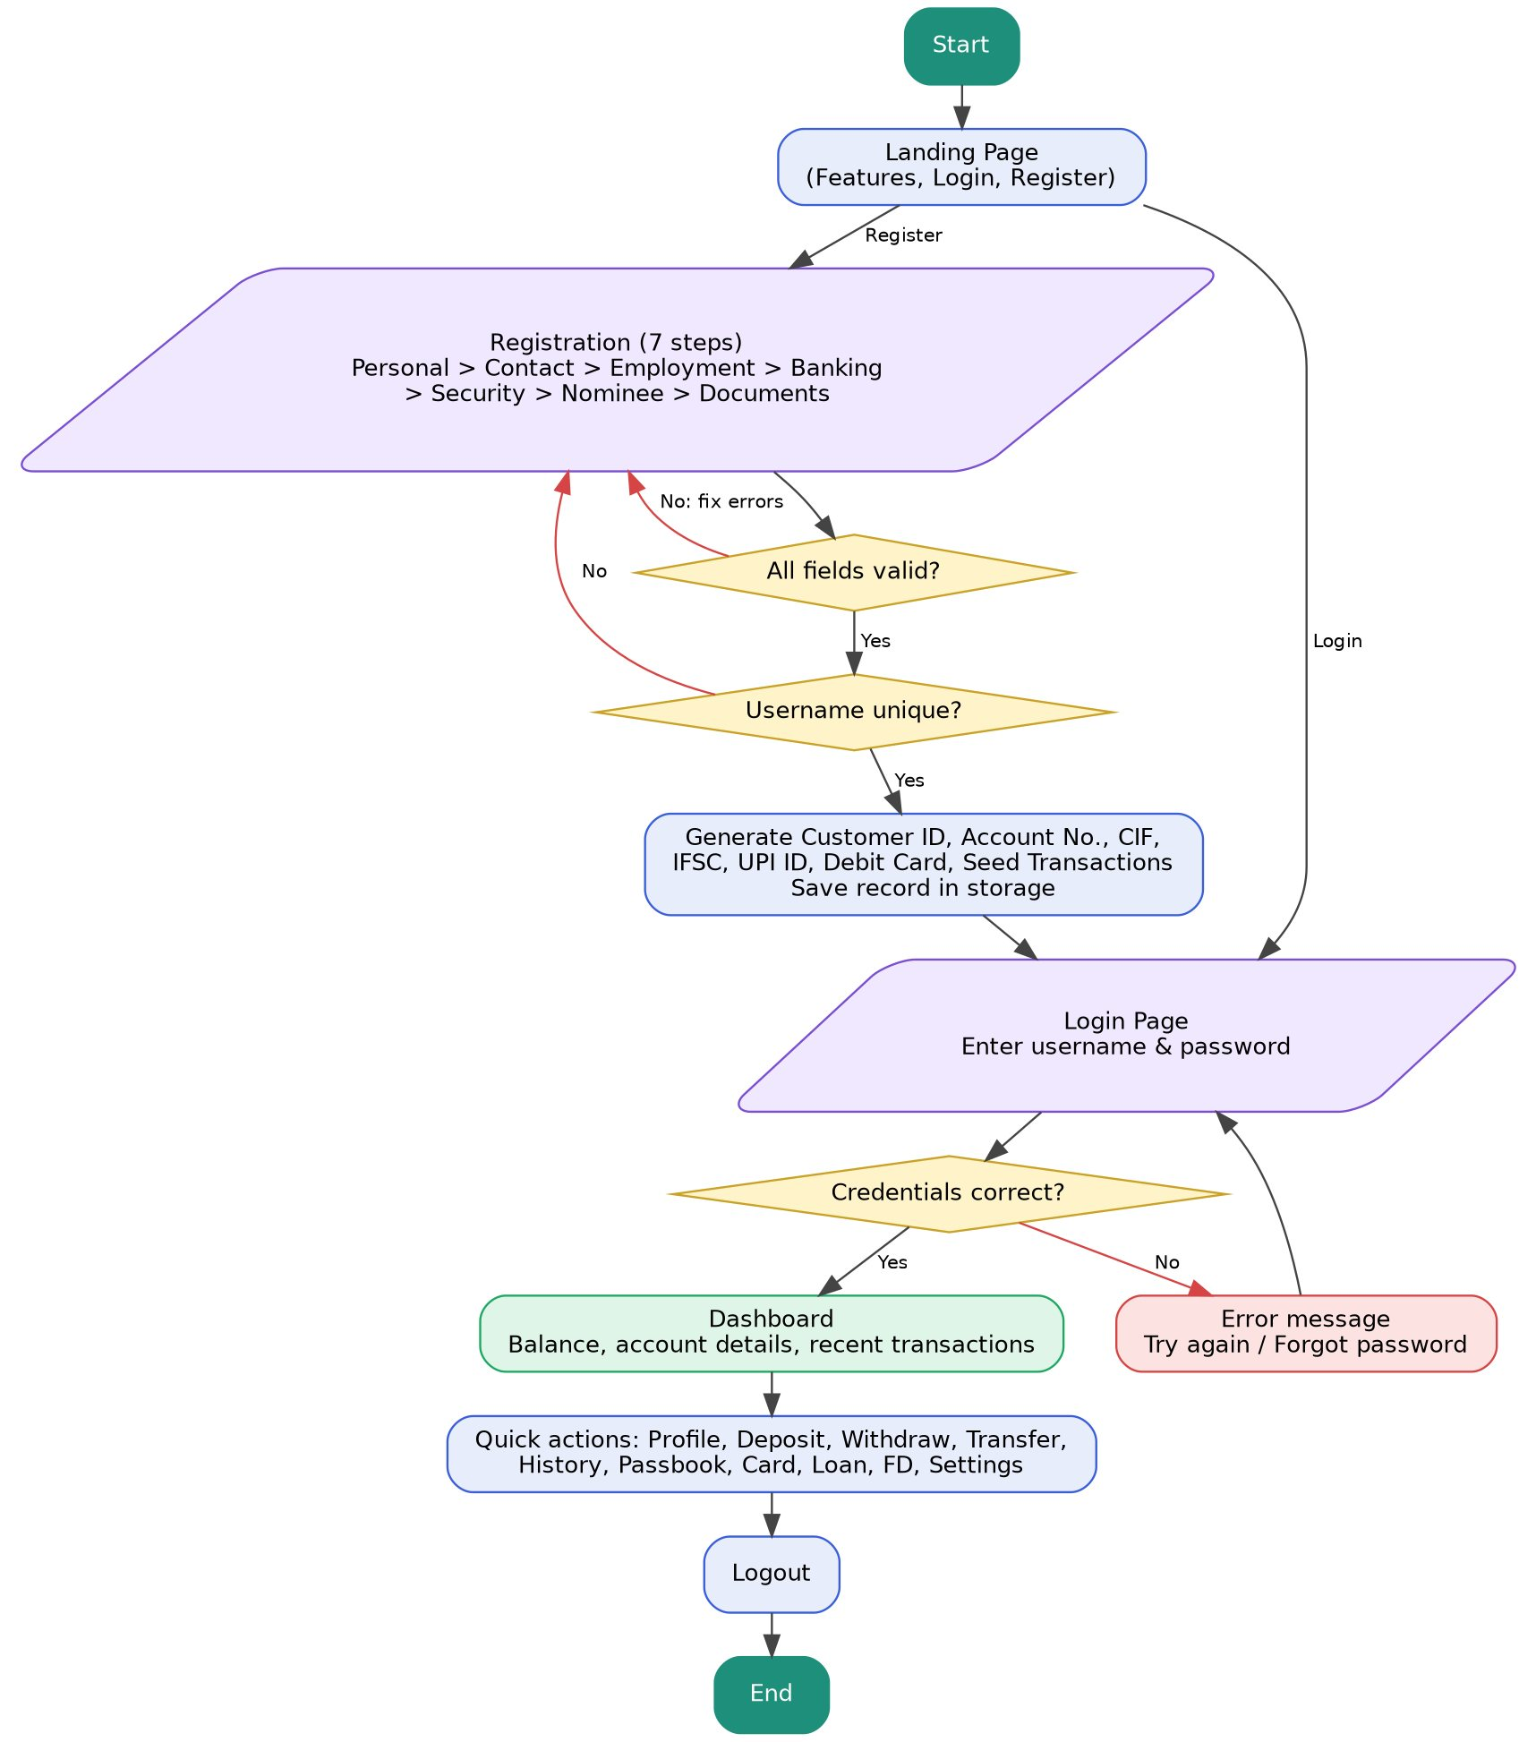
Figure 5.1: Flowchart of the Vaultra Bank portal

5.4 Registration Module
The registration module shows one step at a time with a progress bar and step labels. When Continue is pressed, the current step is validated; only a valid step lets the customer move ahead. The values are remembered when the customer goes Back. The table below lists the steps.
Step | Fields | Validation
1. Personal | Full name, father’s name, mother’s name, date of birth, gender, marital status, nationality, blood group, Aadhaar, PAN, optional passport / licence / voter ID | Letters only for names; Aadhaar 12 digits; PAN ABCDE1234F
2. Contact | Mobile, alternate mobile, e-mail, alternate e-mail, address fields, city, district, state, country, PIN code | Mobile 10 digits (6-9 start); valid e-mail; PIN 6 digits
3. Employment | Occupation, employment type, company, designation, experience, monthly and annual income, education | Incomes greater than 0
4. Banking | Branch, account type, initial deposit and nine service toggles | Minimum deposit ₹500
5. Security | Username, password, confirm password, transaction PIN, security question and answer | Strong password; passwords match; PIN 4-6 digits; unique username
6. Nominee | Name, relationship, age, mobile, address | Name letters only; mobile 10 digits
7. Documents | Passport photo, Aadhaar card, PAN card, signature, address proof; three declarations | All files and declarations required

5.5 Login Module
The login module accepts the username and password and compares them with the saved customers. For correct credentials a verification progress window is shown and the dashboard opens; otherwise an error message is displayed. The Forgot Password option asks for the username, shows the saved security question and, if the answer is correct, lets the customer set a new strong password. The logged-in username is kept so that the dashboard reopens after a page reload until the customer logs out.

5.6 Dashboard Module
The dashboard module reads the logged-in customer’s record and shows (a) information cards for balance, account number, Customer ID, CIF, IFSC, branch, account type, UPI ID, service status, KYC, nominee and opening date; (b) twelve quick-action buttons – View Profile, Edit Profile, Deposit, Withdraw, Transfer, Transaction History, Download Passbook, Card Details, Loan Eligibility, Fixed Deposit, Settings and Logout; and (c) a table of the five most recent transactions. Each action opens a pop-up window, and every money operation updates the balance and adds a transaction entry.

5.7 Data Storage Design
Each customer is stored as one object in local storage. The main parts of this object are listed below.
Part | Contents
personal | Full name, father’s and mother’s name, date of birth, gender, marital status, nationality, blood group, Aadhaar, PAN and optional identity numbers
contact | Mobile, alternate mobile, e-mail, alternate e-mail, address, city, district, state, country, PIN code
employment | Occupation, employment type, company, designation, experience, monthly and annual income, education
banking | Branch, account type, initial deposit and the nine service toggles
security | Username, password, transaction PIN, security question and answer
nominee | Nominee name, relationship, age, mobile and address
account | Customer ID, account number, CIF, IFSC, UPI ID, balance, KYC and account status, opening date, card number and expiry
transactions | List of entries with ID, date, description, credit, debit, balance and status

The Entity Relationship (ER) diagram in Figure 5.2 shows the logical data model. The customer is the central entity and is linked to the contact, employment, security, nominee, document and account entities. One account has many transactions.
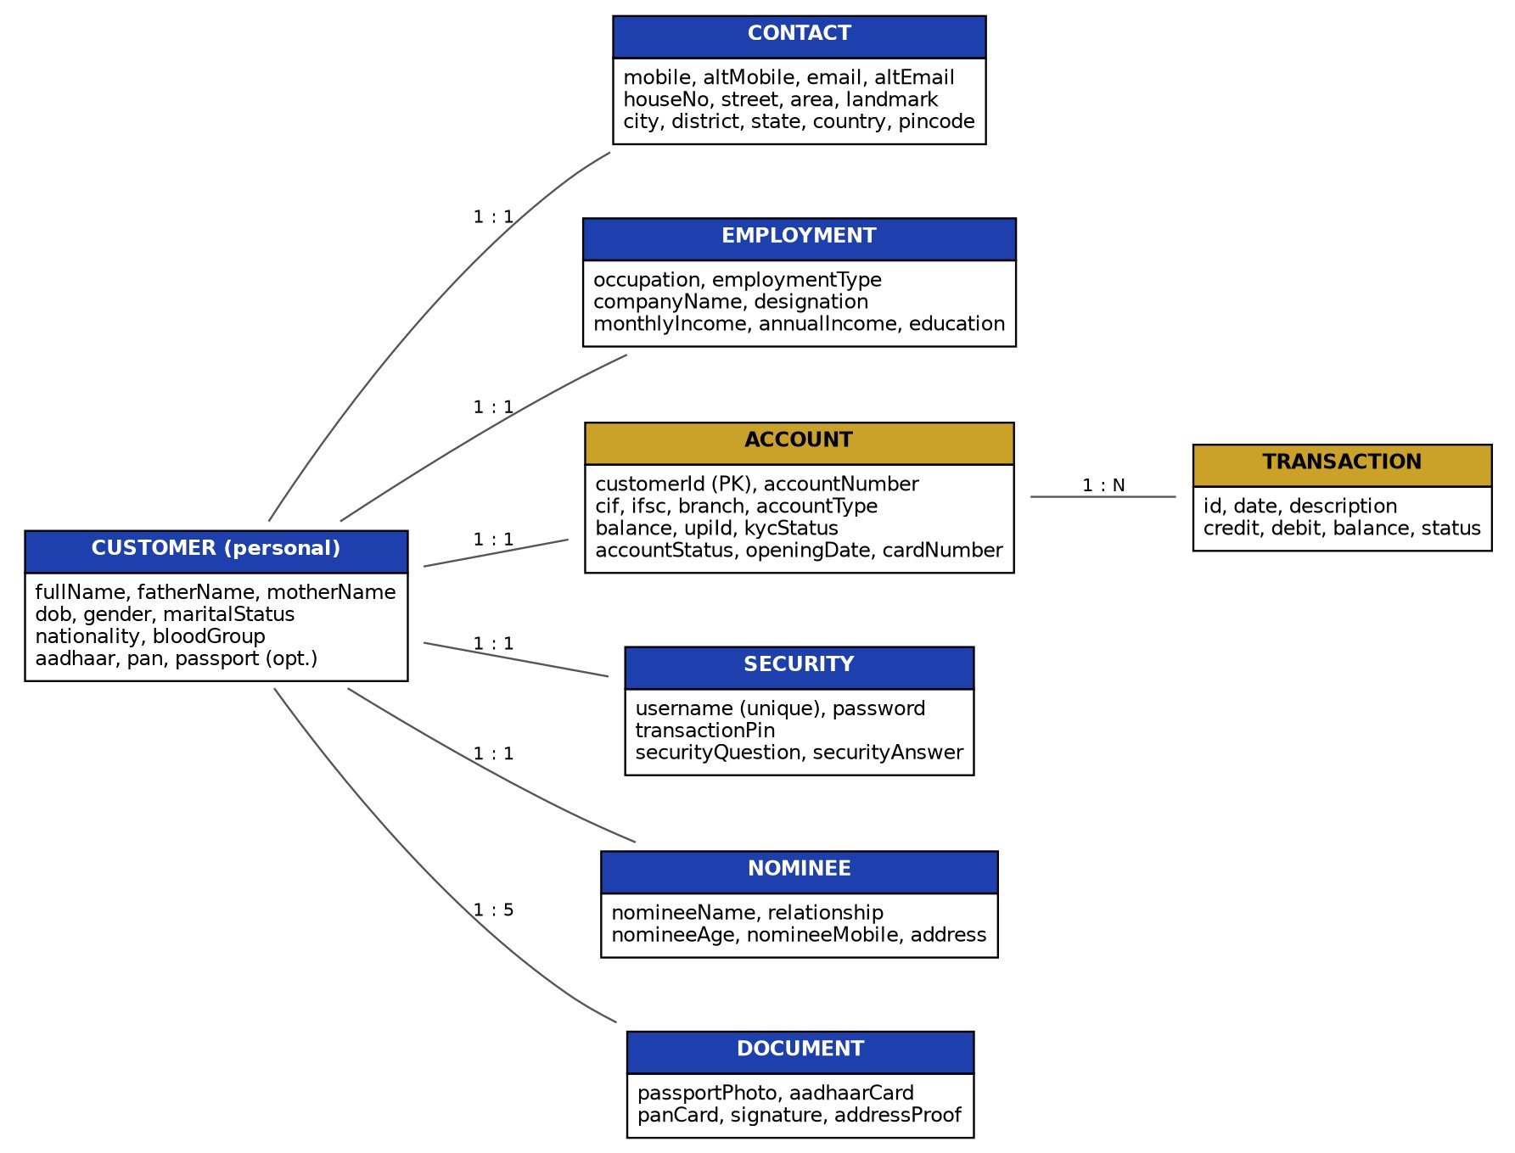
Figure 5.2: Entity Relationship (ER) diagram of the portal
The registration details of a customer were also kept in the MySQL database registration (table registration) managed with phpMyAdmin on the XAMPP server. The columns are id, application_id, candidate_id, application_datetime, reg_no, full_name, department, year, gender, dob, blood_group, nationality, aadhar, email and phone. A stored row is shown in Figure 5.3.
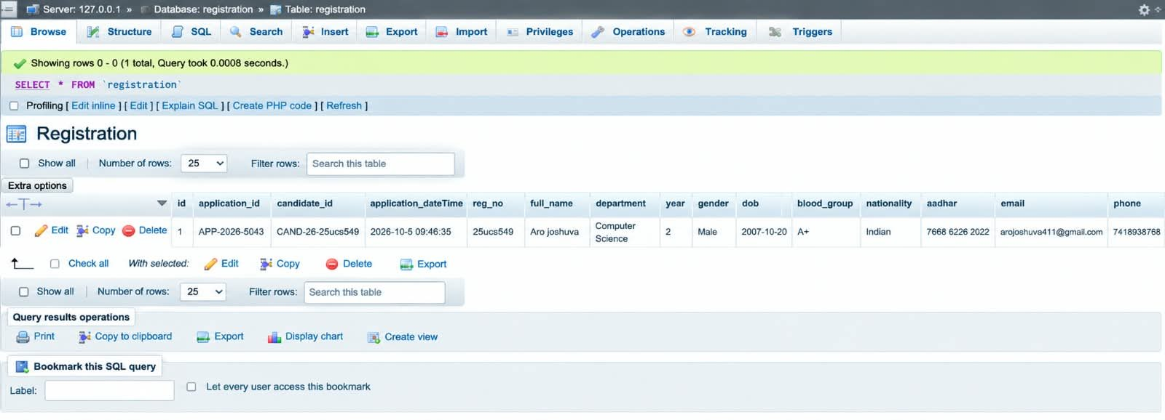
Figure 5.3: phpMyAdmin showing the stored record in table registration

CHAPTER 6: IMPLEMENTATION
This chapter explains the working of the project step by step, in the same order in which a customer uses the system. Every step is supported by a screenshot of the running application.

6.1 Step 1: Opening the Vaultra Bank Website
The website is a single HTML file, index.html. During development it is hosted on the local server of XAMPP version 8.2.12, so the first step is to start the required modules.
- Open the XAMPP Control Panel (v3.3.0) from the installation folder (e:\project\ on the development computer).
- Start Apache and MySQL: both module names turn green; Apache uses ports 80 and 443 and MySQL uses port 3306.
- Check the log window: it shows “Status change detected: running” for Apache and MySQL, which confirms that the server and the database are ready.
The website is then opened in a browser such as Chrome. The panel also shows a notice that it is not running with administrator rights, which is harmless for this project.
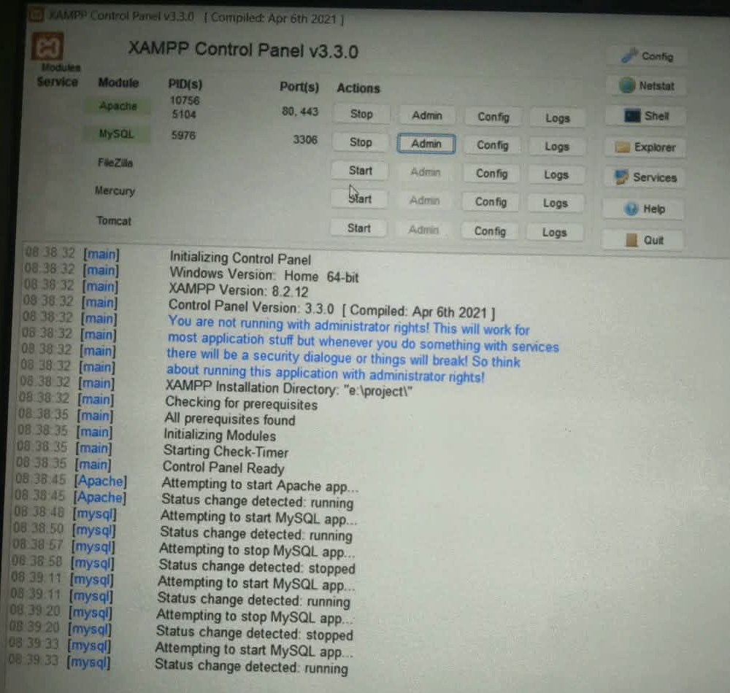
Figure 6.1: XAMPP Control Panel with Apache and MySQL running

6.2 Step 2: Landing Page
The first page shown is the landing page of Vaultra Bank. It contains:
- Navigation bar: the animated Vaultra logo with the Login and Register buttons.
- Hero section: the heading “Banking built like a vault, run like an app”, a short description, the Open an Account and Sign In buttons and a virtual debit card.
- Feature cards: Instant Account Opening, Free Virtual Debit Card, UPI & Mobile Banking, Bank-Grade Security, Fixed Deposits and 8 Branches Nationwide.
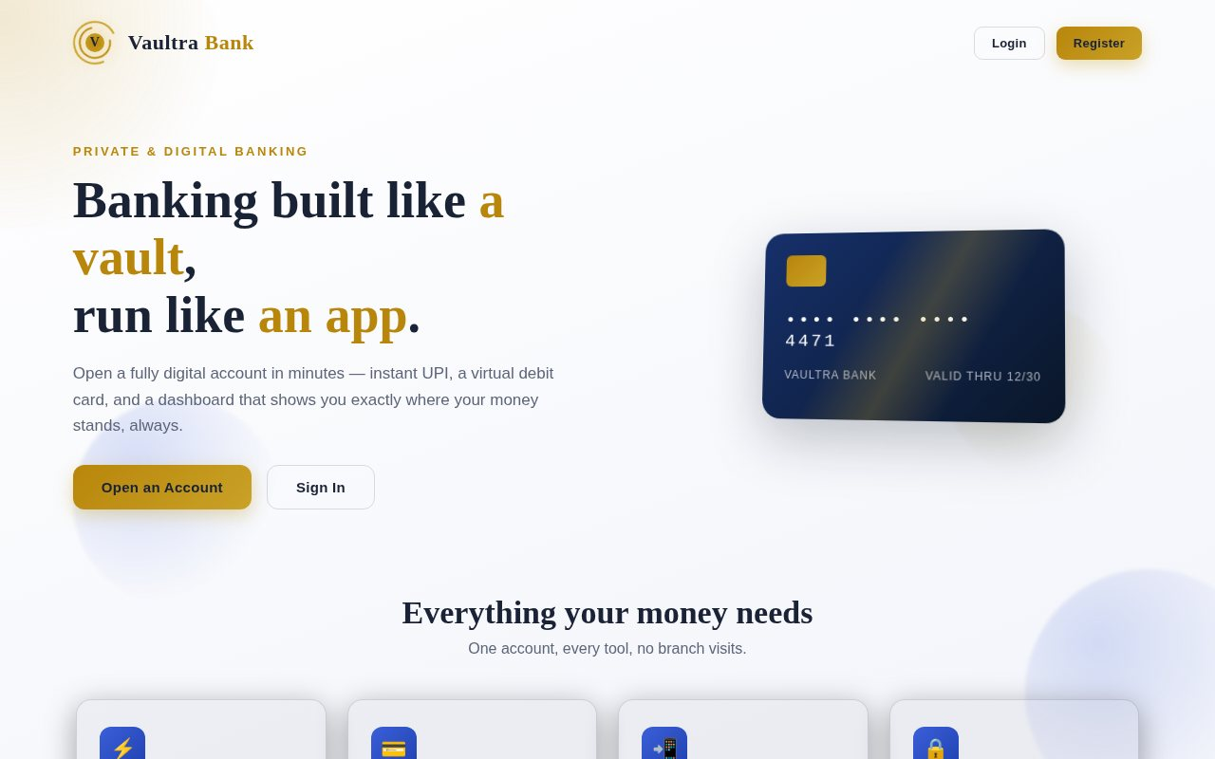
Figure 6.2: Landing page of Vaultra Bank

6.3 Step 3: Account Registration
Clicking Register or Open an Account opens the “Open your account” page. A progress bar and the step labels Personal, Contact, Employment, Banking, Security, Nominee and Documents show that the registration has seven steps. The customer moves forward with Continue and back with Back, or leaves with Cancel.
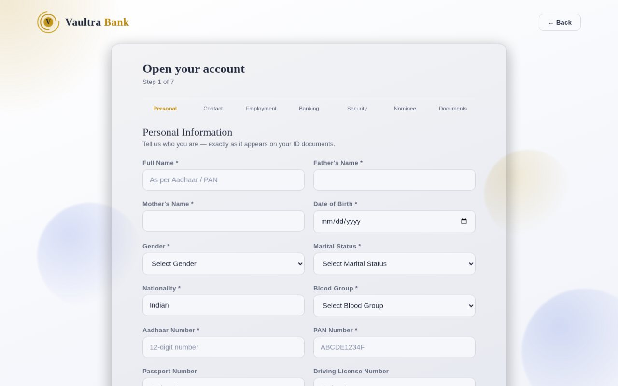
Figure 6.3: Registration page

6.4 Step 4: Personal Information
Step 1 collects the full name, father’s and mother’s names, date of birth, gender, marital status, nationality (pre-filled as Indian), blood group, Aadhaar number, PAN number and the optional passport, driving licence and voter ID numbers. Names accept only letters, the Aadhaar field accepts only 12 digits and the PAN must follow the format ABCDE1234F.
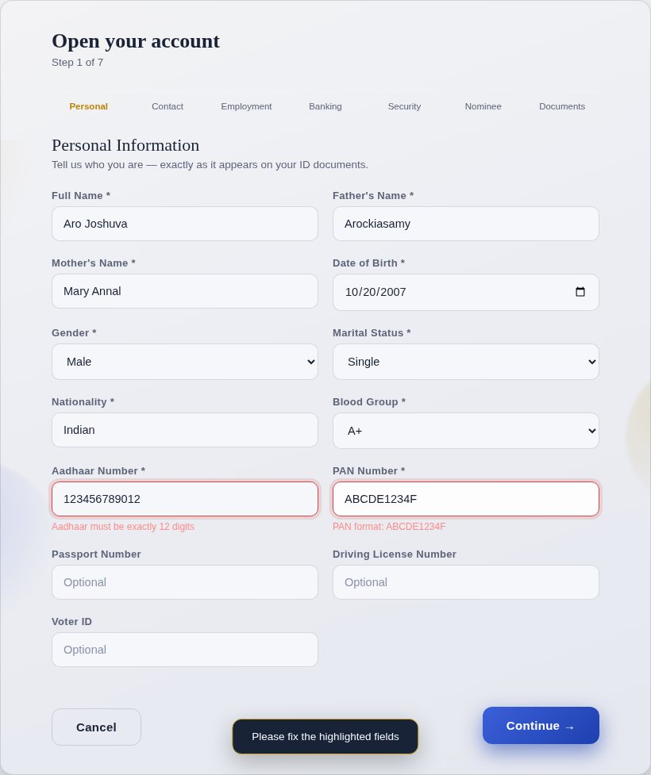
Figure 6.4: Step 1 – Personal Information

6.5 Step 5: Contact Information
Step 2 collects the mobile number, alternate mobile number, e-mail, alternate e-mail and the full address (house number, street, area, landmark, city, district, state, country and PIN code). The mobile number must be 10 digits starting with 6, 7, 8 or 9 and the PIN code must be 6 digits.
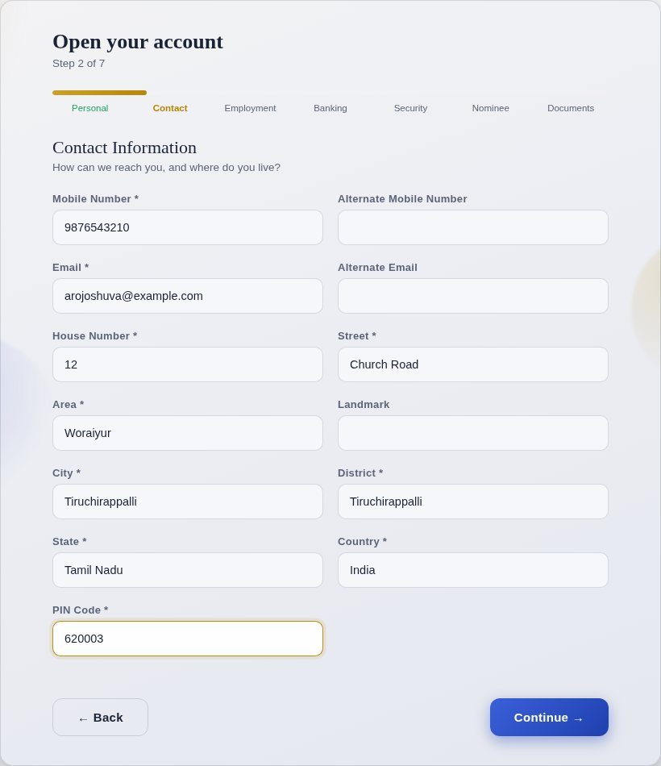
Figure 6.5: Step 2 – Contact Information

6.6 Step 6: Employment Details
Step 3 records the occupation, employment type (Salaried, Self-Employed, Business Owner, Student, Retired, Unemployed), company, designation, work experience, monthly income, annual income and educational qualification. The monthly income is later used by the loan eligibility service.
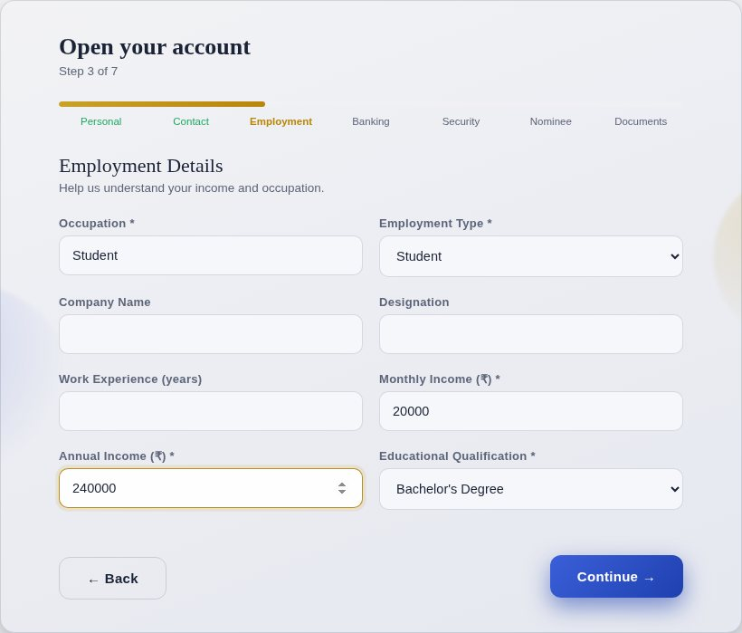
Figure 6.6: Step 3 – Employment Details

6.7 Step 7: Banking Details
Step 4 lets the customer choose the branch from eight cities, the account type (Savings, Current, Salary or Senior Citizen) and the initial deposit, which must be at least ₹500. Nine service toggles – Debit Card, Credit Card, Cheque Book, Passbook, Internet Banking, Mobile Banking, SMS Alerts, UPI Registration and ATM Facility – can be switched on or off. The chosen branch decides the IFSC code.
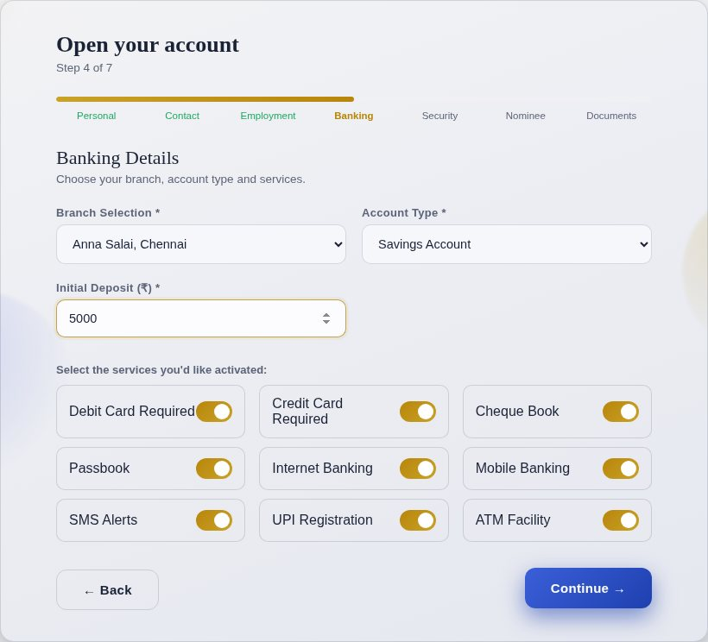
Figure 6.7: Step 4 – Banking Details

6.8 Step 8: Account Security
Step 5 creates the login credentials: a unique username, a password with a SHOW / HIDE button, a confirm-password field, a 4 to 6 digit transaction PIN, a security question and its answer. The password must contain at least 8 characters with one capital letter, one digit and one symbol.
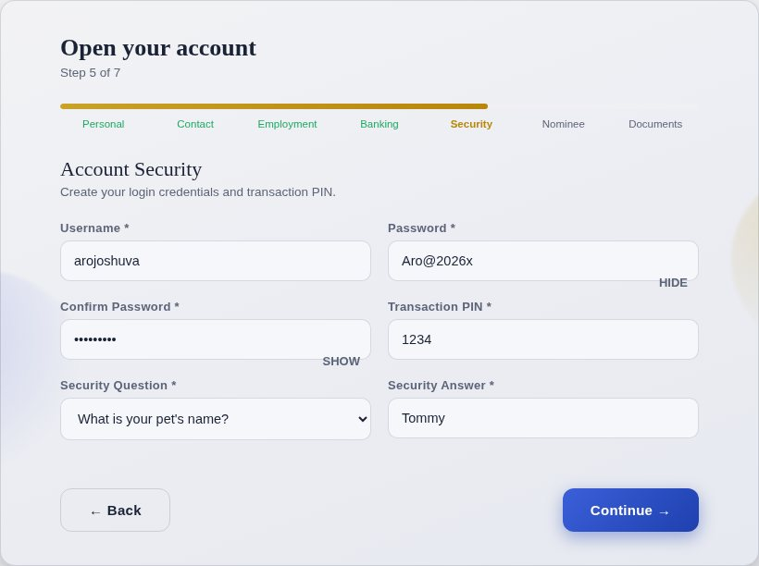
Figure 6.8: Step 5 – Account Security

6.9 Step 9: Nominee Details
Step 6 adds a nominee to the account with the name, relationship (Spouse, Son, Daughter, Father, Mother, Sibling, Other), age, mobile number and address.
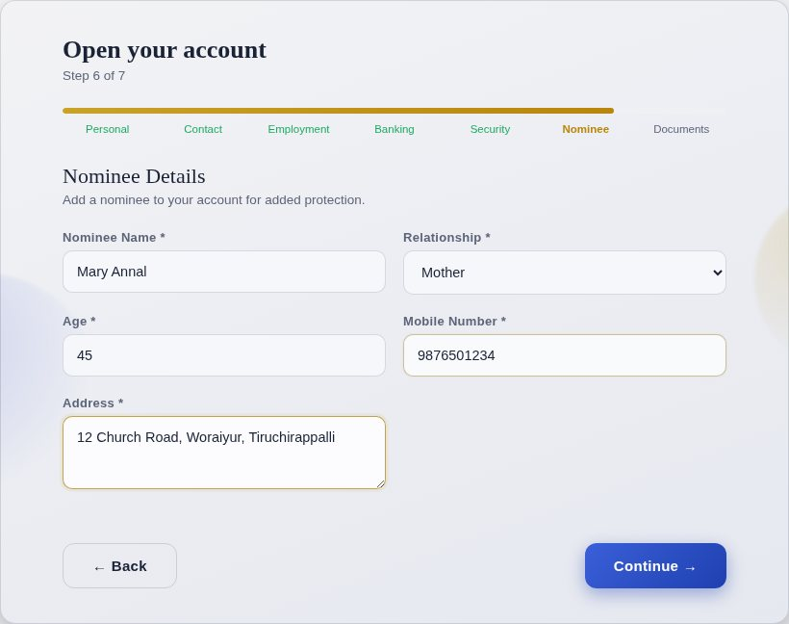
Figure 6.9: Step 6 – Nominee Details

6.10 Step 10: Document Upload
Step 7 asks for the passport photo, Aadhaar card, PAN card, signature and address proof. Each upload box turns green and shows the file name once a file is chosen. The passport photo becomes the profile picture on the dashboard. The customer must also accept the Terms and Conditions, the Privacy Policy and the declaration that the information is true. The Finish Registration button then creates the account.
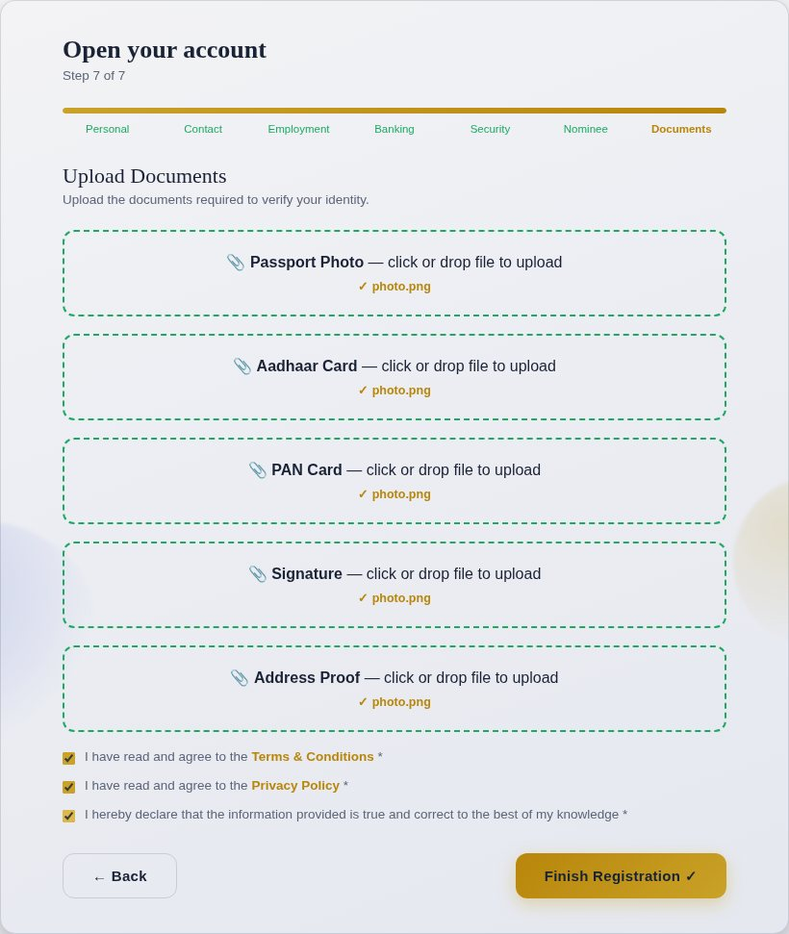
Figure 6.10: Step 7 – Documents and declarations

6.11 Step 11: Form Validation
Every step is checked when Continue is pressed. Empty required fields are highlighted in red with the message “This field is required” and a toast says “Please fix the highlighted fields”. Wrong formats show a specific message, for example “Aadhaar must be exactly 12 digits” or “PAN format: ABCDE1234F”. The customer cannot move to the next step until all errors are corrected.
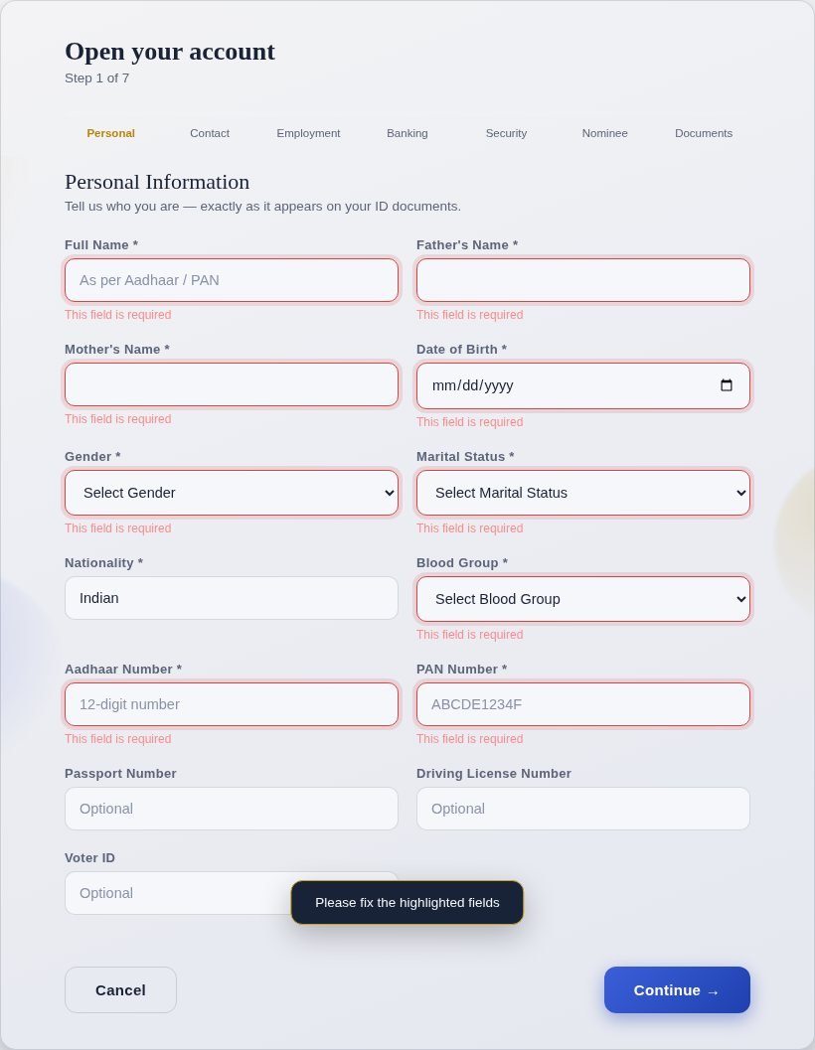
Figure 6.11: Validation of empty required fields
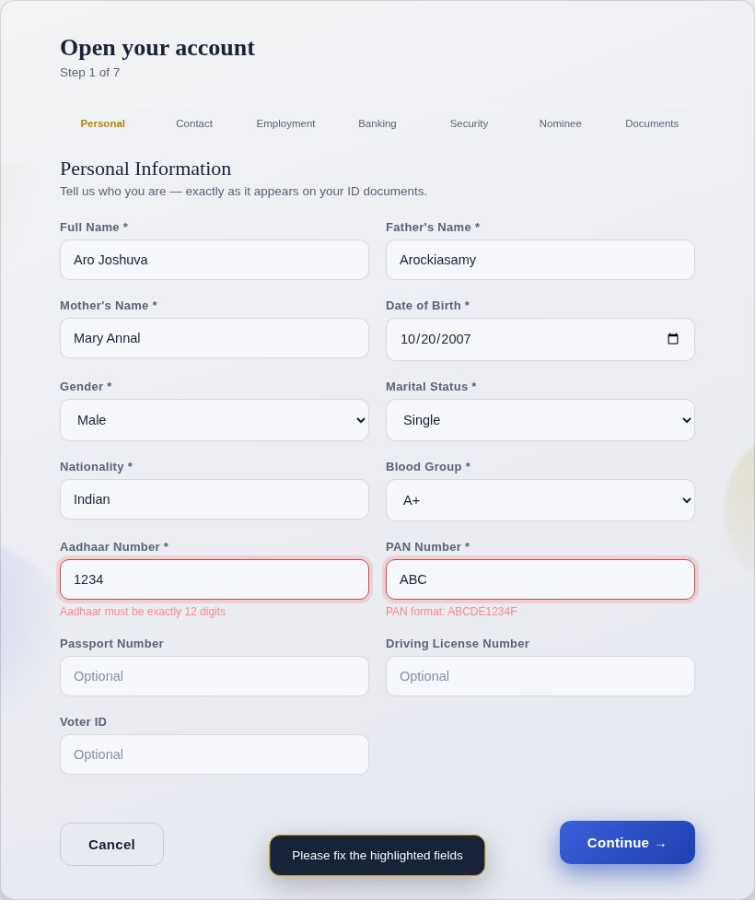
Figure 6.12: Validation of wrong Aadhaar and PAN formats

6.12 Step 12: Registration Confirmation
After Finish Registration the website checks that the username is not already used and shows the “Setting up your account…” window. Eight checks are ticked one by one with a progress percentage: Verifying Personal Details, Checking Identity Documents, Creating Customer ID, Generating Account Number, Creating Debit Card, Activating Internet Banking, Creating UPI ID and Finalizing Registration. The system generates the Customer ID, a 16-digit account number, the CIF number, the IFSC code, the UPI ID (username@vaultra), the card number and expiry date, adds a set of sample transactions and saves the record. A “Registration Successful” message with a confetti animation is displayed and the customer is taken to the login page.
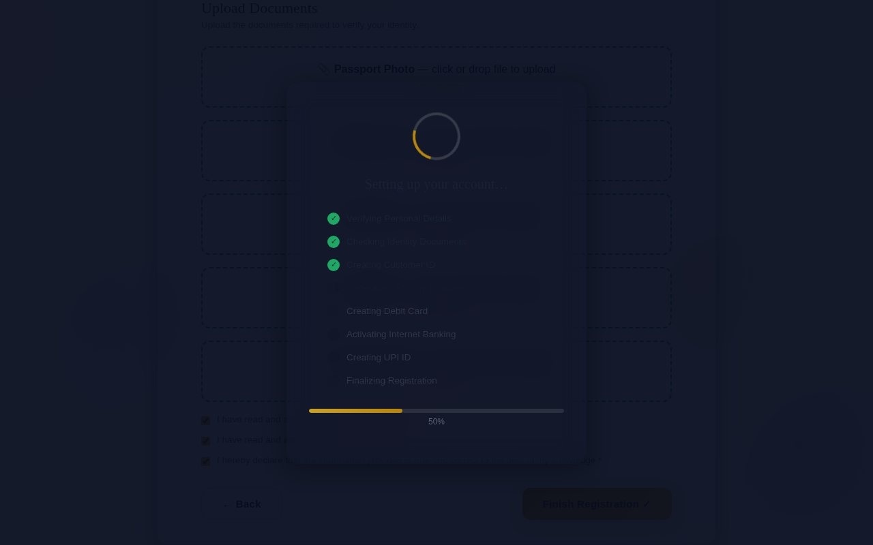
Figure 6.13: Account set-up and verification progress

Figure 6.14: Registration Successful message

6.13 Step 13: Login Page
The login page asks for the username and password. The password box has a SHOW button, and there are a Remember me option and a Forgot password link. The registered username is filled automatically after registration. For wrong credentials an error is displayed. For correct credentials the “Verifying Credentials…” window with a progress bar is shown, followed by “Authentication Successful”, and the dashboard opens.
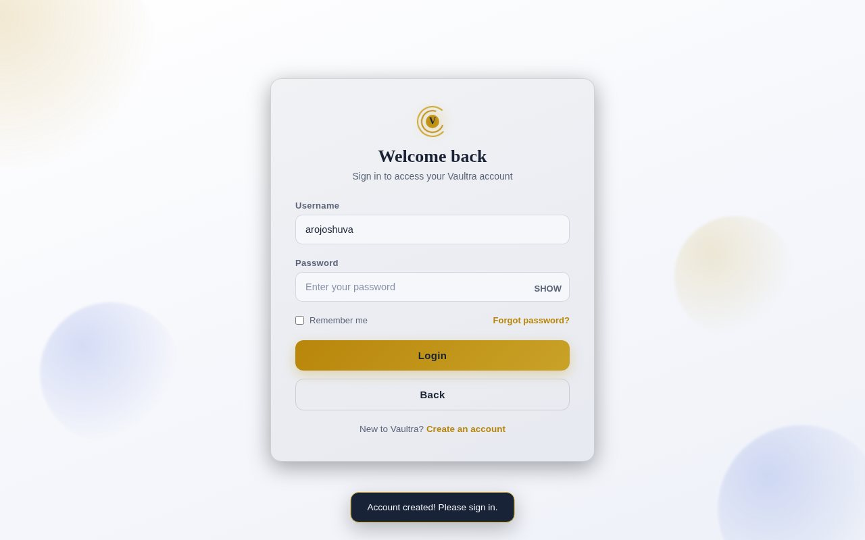
Figure 6.15: Login page
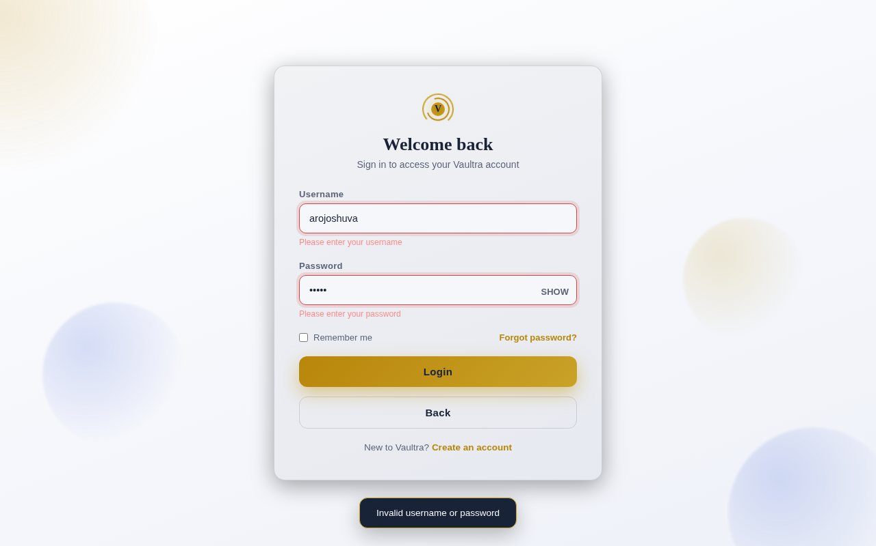
Figure 6.16: Login with wrong credentials

Figure 6.17: Verifying credentials

6.14 Step 14: User Dashboard
The dashboard shows the welcome message with the customer name and Customer ID, the profile picture, the ACTIVE status and the Logout button. The information cards display the Available Balance, Ledger Balance, Account Number, Customer ID, CIF Number, IFSC Code, Branch, Account Type, UPI ID, status of Internet Banking, Mobile Banking, Debit Card and Credit Card, KYC Status, Nominee Status, Account Status and Opening Date.
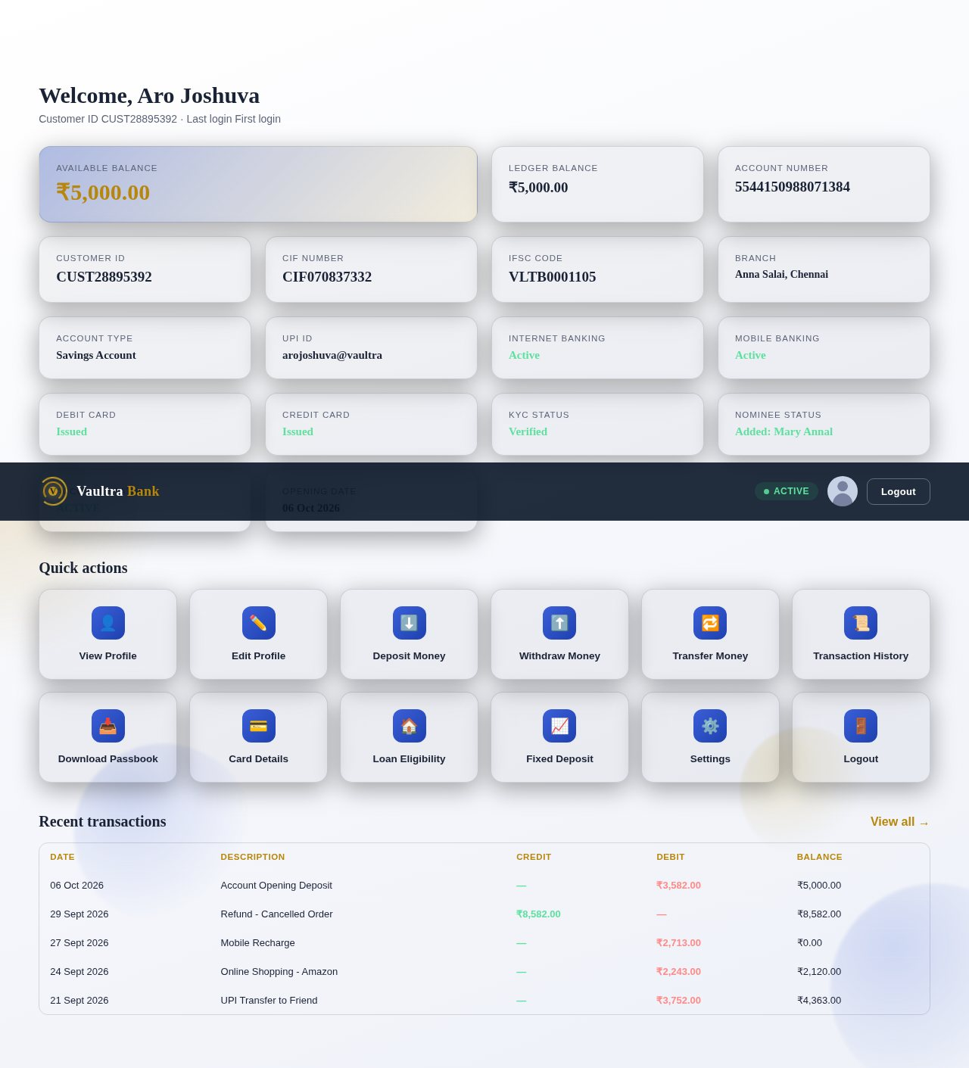
Figure 6.18: Customer dashboard

6.15 Step 15: Banking Services and Quick Actions
The twelve Quick Action buttons open the banking services. Each service opens in a pop-up window.
- View / Edit Profile: lists the personal, contact, employment and nominee details and allows them to be changed.
- Deposit and Withdraw: ask for the amount and remarks; a withdrawal larger than the balance is rejected with “Insufficient balance”.
- Transfer Money: needs a numeric account number, a recipient name with letters only, an amount within the balance and the correct transaction PIN.
- Transaction History: lists all transactions with a search box and an All / Credits / Debits filter; Download Passbook saves the statement as a text file.
- Card Details: shows the virtual debit card, card status, and the daily ATM limit (₹50,000) and POS limit (₹1,00,000).
- Loan Eligibility: estimates the eligible amount from the monthly income for a personal, home or car loan with the interest rate and tenure.
- Fixed Deposit: minimum ₹1,000 for 6 months, 1, 3 or 5 years at 6.0%, 6.8%, 7.2% and 7.5% per annum, with the maturity amount calculated instantly.
- Settings: change password and switch SMS Alerts and Internet Banking on or off.
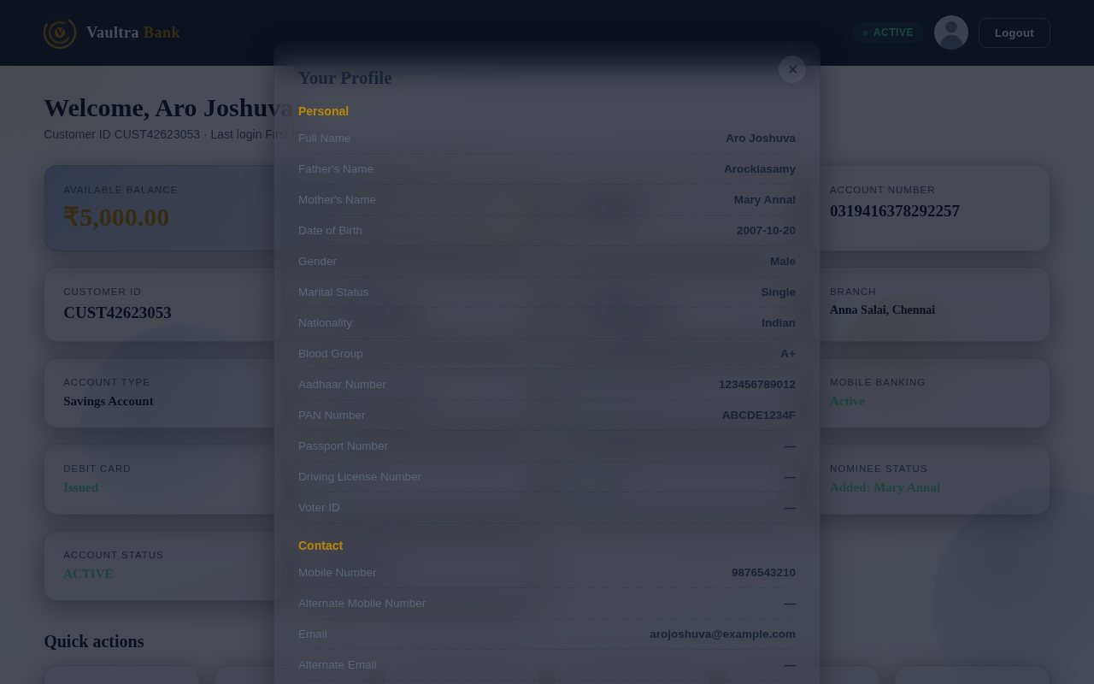
Figure 6.19: View Profile
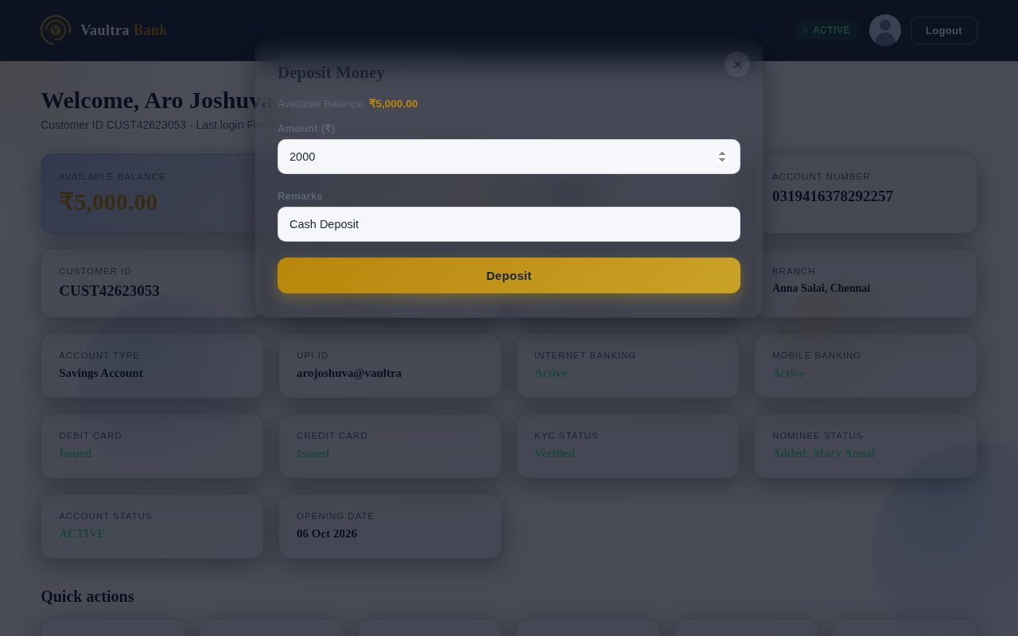
Figure 6.20: Deposit Money
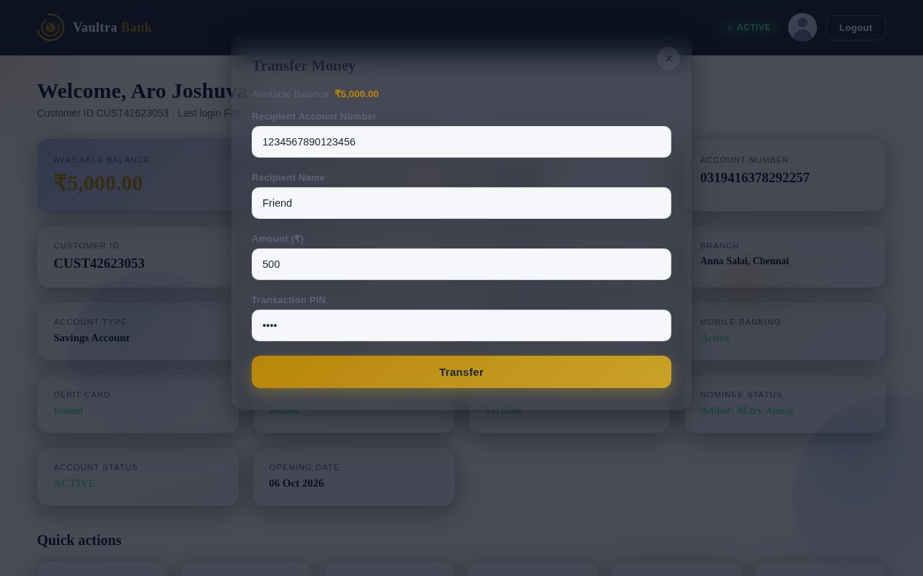
Figure 6.21: Transfer Money
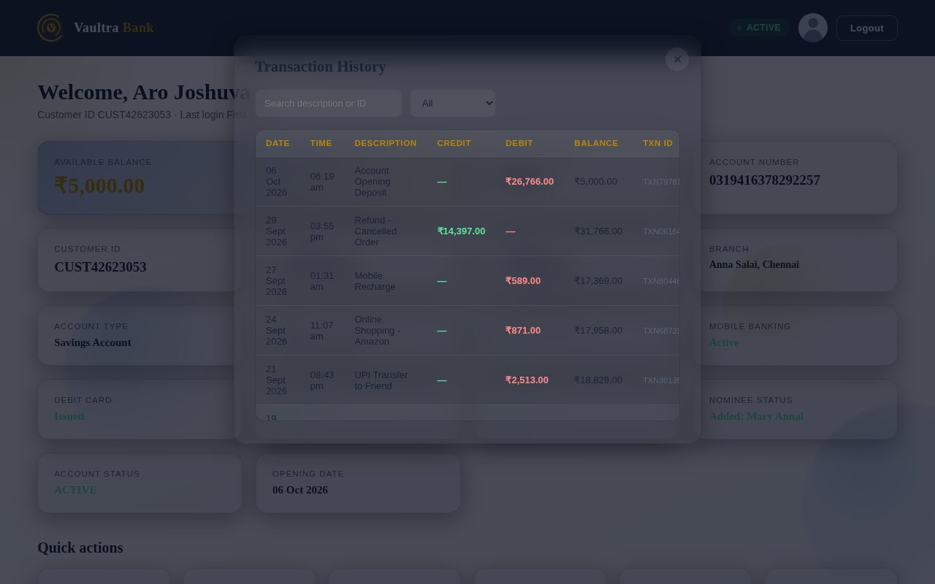
Figure 6.22: Transaction History
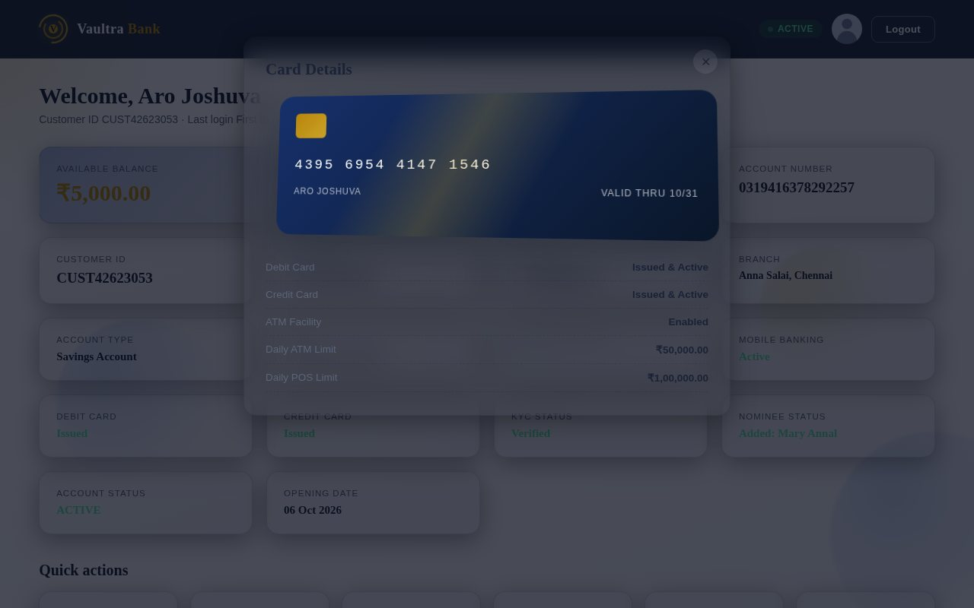
Figure 6.23: Card Details
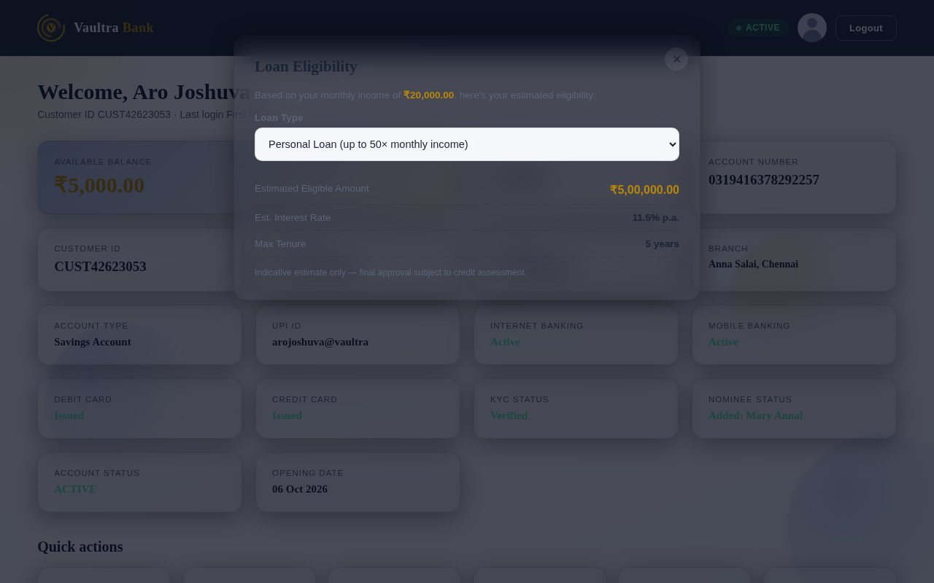
Figure 6.24: Loan Eligibility
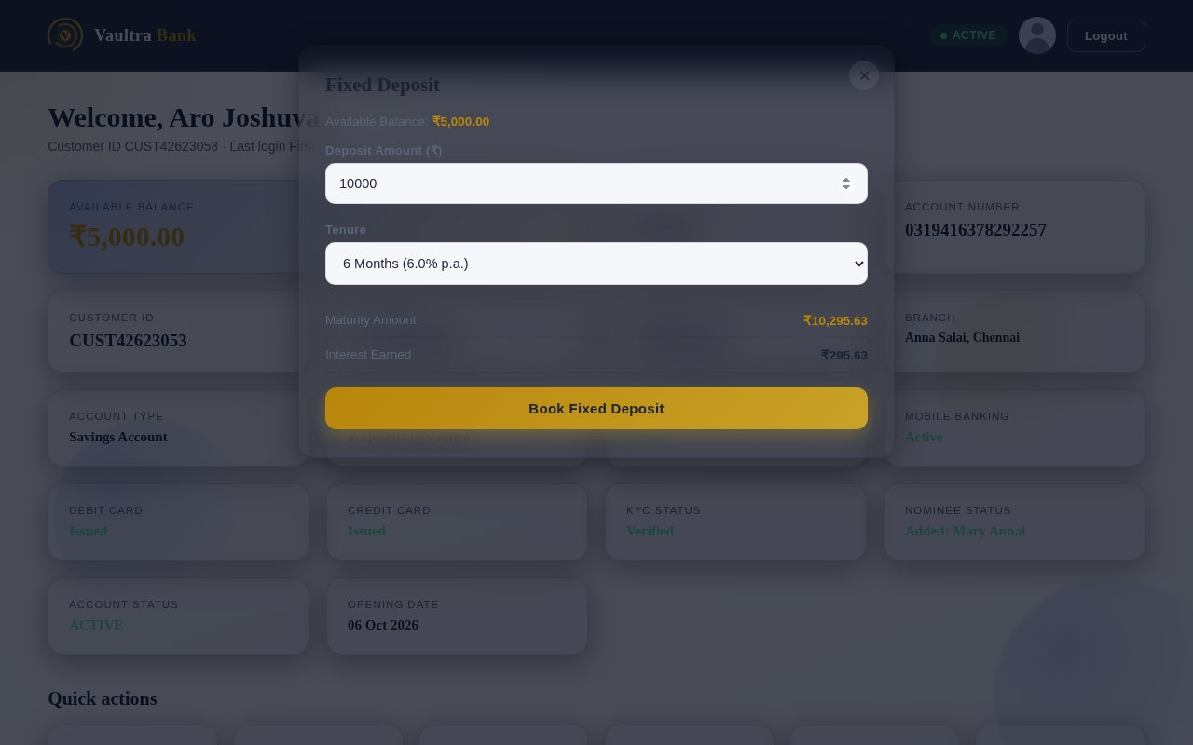
Figure 6.25: Fixed Deposit
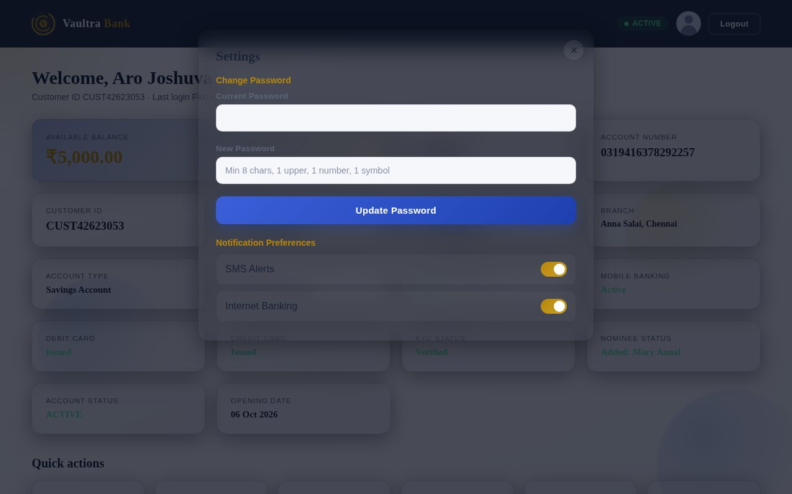
Figure 6.26: Settings

6.16 Step 16: Recent Transactions
Below the quick actions the dashboard lists the five most recent transactions with the date, description, credit, debit and running balance. Credits are shown in green and debits in red. Each deposit, withdrawal, transfer or fixed deposit adds a new row at the top and updates the balance.
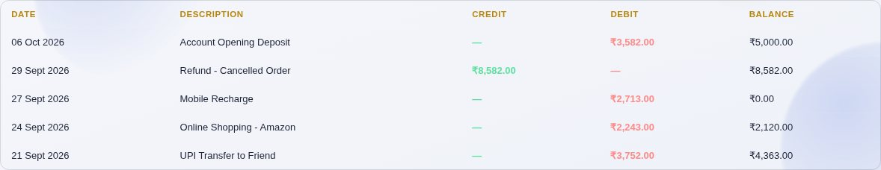
Figure 6.27: Recent transactions table

6.17 Step 17: Logout
Clicking Logout shows a confirmation window. On confirming, the session is cleared, the login form is reset and the customer returns to the login page. The dashboard cannot be opened again without logging in.
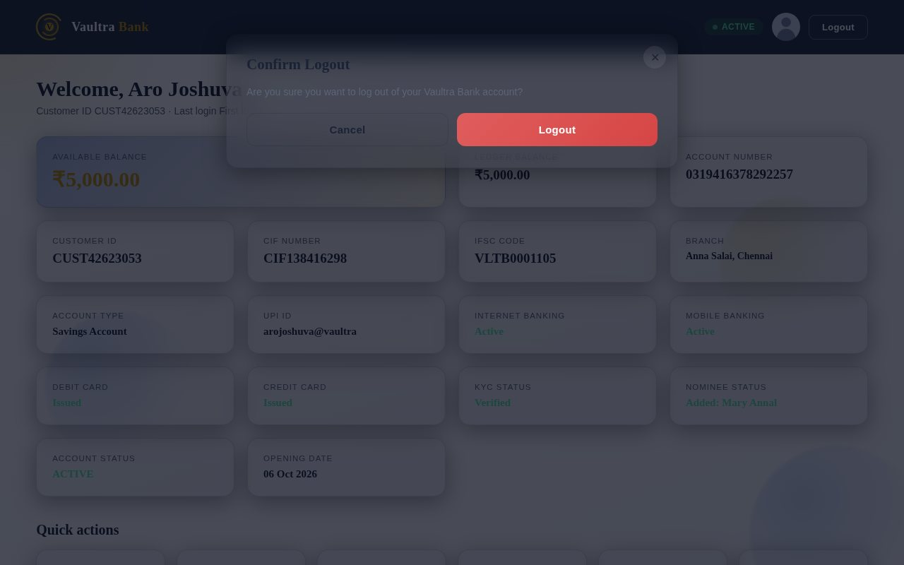
Figure 6.28: Logout confirmation

CHAPTER 7: TESTING

7.1 Testing Approach
The website was tested manually through the browser, following the same sequence of steps as a real customer. Each page was checked for correct display, correct messages, correct calculation and correct storage of data.

7.2 Test Cases
No. | Test case | Expected result | Result
1 | Open the landing page | Hero section and six feature cards are displayed | Pass
2 | Click Register | Registration page opens at Step 1 of 7 | Pass
3 | Complete all seven steps and finish | Verification progress, “Registration Successful” and login page | Pass
4 | Login with correct credentials | “Authentication Successful” and dashboard opens | Pass
5 | Deposit a valid amount | Balance increases and a credit row is added | Pass
6 | Withdraw more than the balance | “Insufficient balance” message | Pass
7 | Transfer with a wrong PIN | “Incorrect transaction PIN” message | Pass
8 | Book a fixed deposit below ₹1,000 | “Minimum FD amount is ₹1,000” message | Pass
9 | Search and filter transaction history | Only matching rows are listed | Pass
10 | Click Logout and confirm | Session ends and login page is shown | Pass

7.3 Form Validation Testing
Field | Test input | Expected result | Result
Full name | Digits or symbols | Rejected; only letters are accepted | Pass
Aadhaar | 1234 (fewer than 12 digits) | “Aadhaar must be exactly 12 digits” | Pass
PAN | ABC | “PAN format: ABCDE1234F” | Pass
Mobile | 1234567890 (starts with 1) | “Enter a valid 10-digit mobile number” | Pass
E-mail | abc@ | “Enter a valid email address” | Pass
PIN code | 12345 | “PIN code must be 6 digits” | Pass
Initial deposit | 200 | “Minimum initial deposit is ₹500” | Pass
Password | password | “Min 8 chars with 1 uppercase, 1 number & 1 symbol” | Pass
Confirm password | Different text | “Passwords do not match” | Pass
Required fields | Left empty | “This field is required” and field highlighted | Pass

7.4 Login Testing
Test case | Expected result | Result
Correct username and password | Verification window and dashboard | Pass
Wrong password | Error message; dashboard not opened | Pass
Unknown username | Error message; dashboard not opened | Pass
Empty username or password | “Please enter your username / password” | Pass
Forgot password with correct answer | New password accepted if strong | Pass
Forgot password with wrong answer | “Security answer incorrect” | Pass

7.5 Registration Testing
Test case | Expected result | Result
Continue with a step incomplete | Step is not changed; errors highlighted | Pass
Back button after filling a step | Entered values are retained | Pass
Finish without uploading all documents | Missing upload boxes highlighted | Pass
Finish without accepting declarations | Declarations highlighted | Pass
Register with an existing username | “Username already taken” and return to Security step | Pass
Valid registration | Account created and record saved | Pass

7.6 Test Observations
The main workflow from registration to logout works as designed. The validation rules prevent incorrect data from being accepted, the dashboard calculations update the balance and transaction list correctly, and the saved customer is available again after a page reload.

CHAPTER 8: CONCLUSION AND FUTURE ENHANCEMENT

8.1 Conclusion
The Vaultra Bank Portal successfully demonstrates how the manual account-opening process of a bank can be replaced by an easy-to-use online system. Using HTML, CSS and JavaScript with local storage, the website provides a landing page, a validated seven-step registration form, automatic generation of account details, secure login, a full-featured dashboard and permanent storage of the customer record in the browser.
The project helped the author to understand web page design, form validation, client-side programming and browser storage, and shows how a routine banking process can be improved through simple, low-cost technology. It also supports the Sustainable Development Goals by reducing paper use (SDG 12), promoting digital financial services for all (SDG 8) and encouraging innovation in digital infrastructure (SDG 9).

8.2 Limitations
- The data is stored only in the browser’s local storage, so it is available only on the same browser and computer.
- There is no server-side validation, and passwords are stored without encryption.
- Uploaded documents are only recorded by file name and are not verified.
- Transactions are simulated; no real money or real payment network is involved.
- There is no administrator panel for the bank staff.

8.3 Future Enhancements
- A server-side back end (PHP and MySQL) so that customers, passwords and transactions are stored in a database.
- Passwords stored in encrypted (hashed) form, with OTP verification through e-mail or SMS.
- An administrator panel for bank staff to verify KYC documents and approve accounts.
- Real UPI and payment-gateway integration with transaction limits and fraud checks.
- Download of the statement and passbook as PDF and e-mail notifications.
- A mobile application and multi-language support.

CHAPTER 9: BIBLIOGRAPHY
Web references
- MDN Web Docs, HTML, CSS and JavaScript reference. https://developer.mozilla.org
- W3Schools, HTML, CSS and JavaScript tutorials. https://www.w3schools.com
- MDN Web Docs, Window.localStorage. https://developer.mozilla.org/en-US/docs/Web/API/Window/localStorage
- MDN Web Docs, Responsive web design. https://developer.mozilla.org/en-US/docs/Learn/CSS/CSS_layout/Responsive_Design
- MDN Web Docs, Regular expressions. https://developer.mozilla.org/en-US/docs/Web/JavaScript/Guide/Regular_expressions

